For Lease – Restaurant/Retail Space
949 Forest Avenue, Portland, Maine

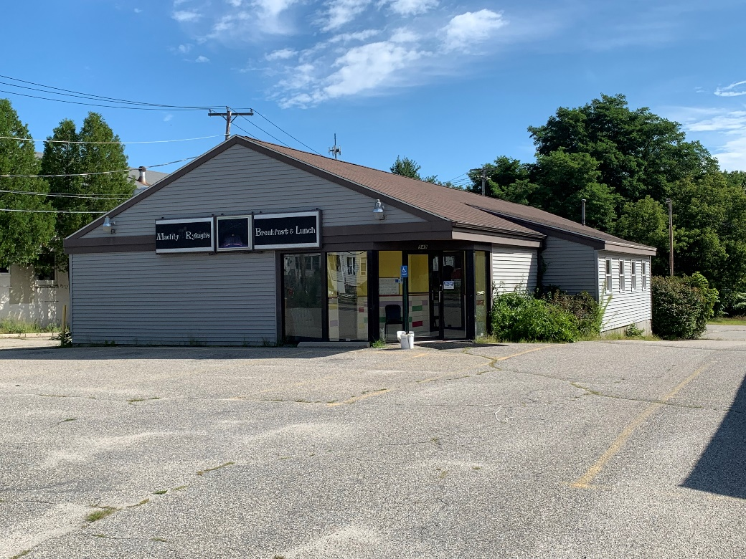

4,185 +/- sf Freestanding Restaurant/Retail Space

Location: 949 Forest Avenue, Portland, Maine
Presented By:

Akers Associates, Inc.
408 Fore Street
Portland, ME 04101

Andrew Juris
(O) 207-774-8300
Andrew@Akersassociates.com

Available Space: 4,185 +/- SF of Freestanding Restaurant/Retail Space

Types Of Uses: Restaurant/Retail

Building Size: 4,185 +/- SF

Zoning: B2 – Community Business

Lease Rate: $19.00/SF Triple Net (NNN)

Akers Associates, Inc. is representing the Seller/Landlord in the marketing, negotiation and sale and/or lease of this property. While information furnished is from sources deemed reliable, no warranty or representation, express or implied, is made as to the accuracy of information contained herein, and same is submitted subject to errors, omissions, change of price, rental or other conditions, withdrawal without notice and to any special listing conditions imposed by our principals.

Property Summary

Available for lease is a freestanding building located at 949 Forest Avenue in Portland, Maine. Located along one of Portland’s major arteries this freestanding building experiences a tremendous amount of traffic and visibility to go along with an abundance of on-site parking and yard space. The property has historically been operated as a restaurant containing a full kitchen with built in hood systems, commercial kitchen plumbing, natural gas for heat and kitchen appliances, built in walk in cooler, 2 sets of bathrooms, built in bar/counter, central air conditioning, high ceilings and open floor plan in dining area. The building also contains a 1,000 +/- sf basement used for storage, utilities and support for the kitchen. Furthermore restaurant equipment is available for the prospective tenant.

Top of Form
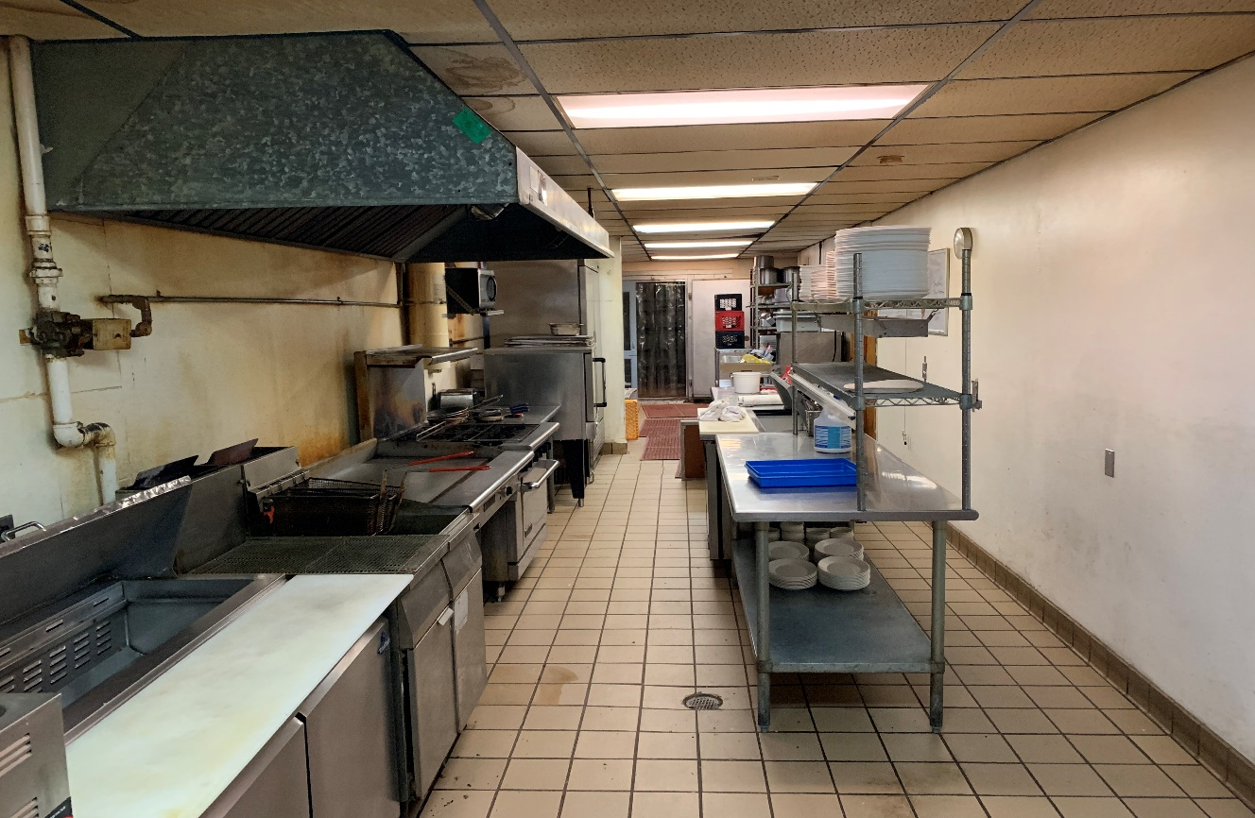 Bottom of Form
Top of Form

Top of Form
Bottom of Form

ADDRESS: 949 Forest Avenue TOTAL BUILDING SIZE: 4,185 +/- SF
Portland, Maine

OWNER: 949 Forest Avenue, LLC PROPERTY SIZE: 0.54 +/- Acres

ZONE DISTRICT: B2 – Community Business HEATING: Gas & Electric – Hot Air

AIR CONDITIONING: Central Air System ELECTRICITY: 200 Amp
Electric

WATER & SEWER: Municipal RESTROOMS: 1 Full Set

HOOD SYSTEMS: Existing Hoods EXISTING EQUIPMENT: FF&E Can Be Purchased
Separately

LEASE RATE: $19.00/SF NNN PARKING: Abundant

TRIPLE NET (Tax & Insur): $3.96/SF AVAILABILITY: October 2019

Aerial

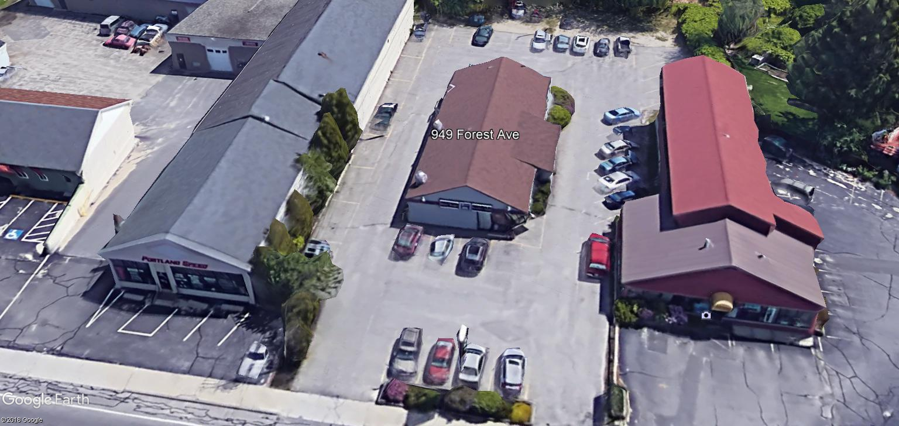

Traffic Count (2017): – 19,540 automobiles per day - Maine Depart. of Transportation

Additional Pictures

